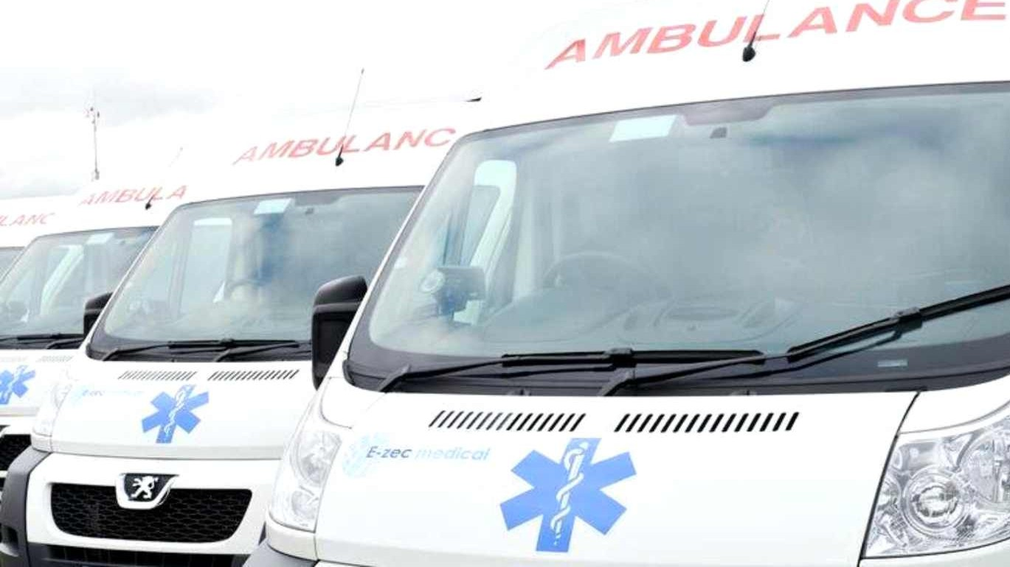
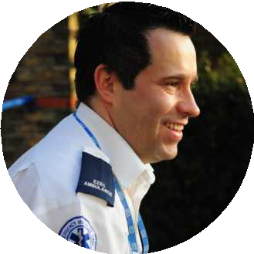

Patient Transport Service from 1 April 2017

From 1 April 2017, non-emergency patient transport will be provided by E-zec Medical Transport Services.
The patient transport service (PTS) provides planned, non-emergency transport for patients to and from NHS hospitals and clinics in Bristol, North Somerset and South Gloucestershire.

It is only available for eligible patients who need the support of clinically trained staff and / or medical equipment during their journey.

From 1 April 2017, the way patient transport is booked will also change. From this date the patient or patient’s carer will be responsible for requesting transport.
If you have already made a booking, you don’t need to do anything as all the bookings will be automatically transferred to
E-zec.

New bookings can be made on the number below from 13 March 2017

Booking office and enquiries
T: 0300 777 6688

